**Experiment # 04**

**Switches with Servo and Stepper motors**

Section: 3 - 1

Group Number: 5

Members:

CASAMORIN, Jay

CHIU, John Kristian

MEDIAVILLO, Carl Lewis

Procedure:

1.Connect two simple switches in your Arduino uno board with step-up resistor to have a normally LOW input to Arduino.

2. Connect the Servo motor and the stepper motor directly to Arduino board.

3. Switch 1 will operate Servo motor.

4. Switch 2 will operate Stepper motor.

5. Place a lightweight wooden bar at the end of each motor to indicate that it is turning.

Source Code:

**STEP MOTOR**

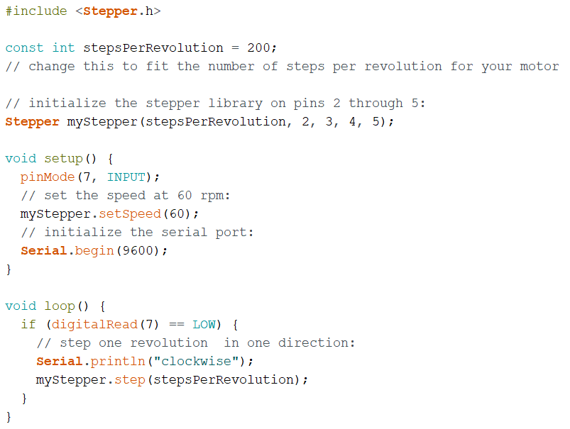

**SERVO MOTOR**

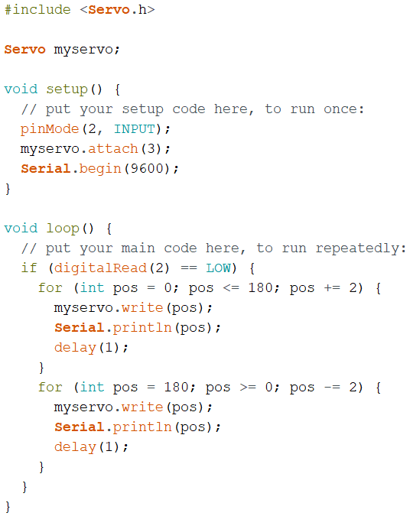

Circuit Diagram:

**STEP MOTOR**

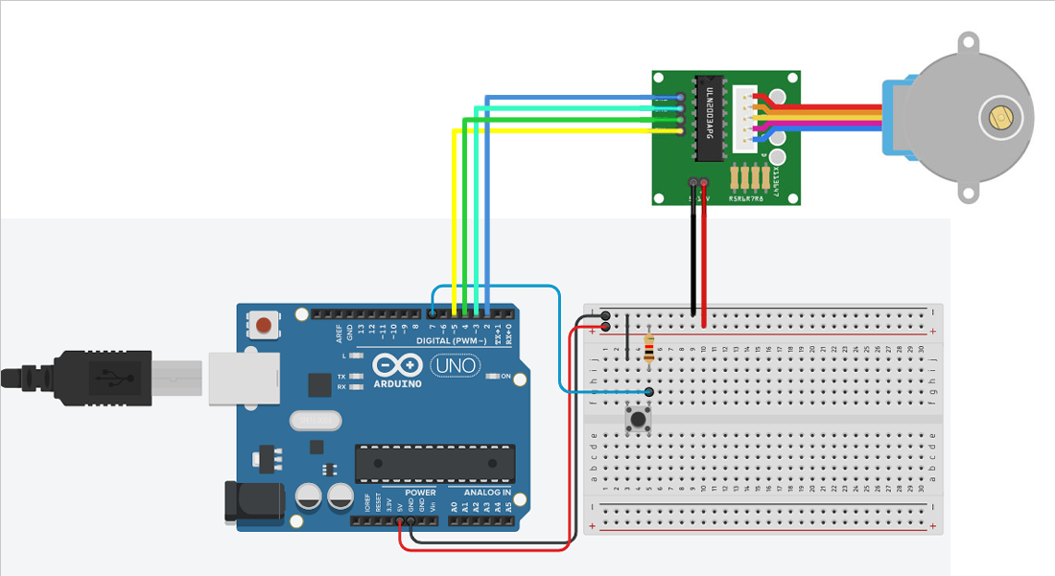

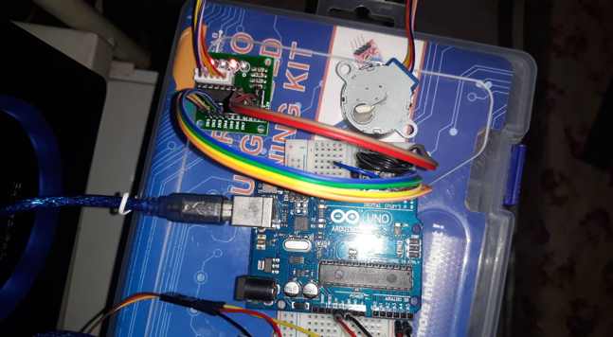

**SERVO MOTOR**

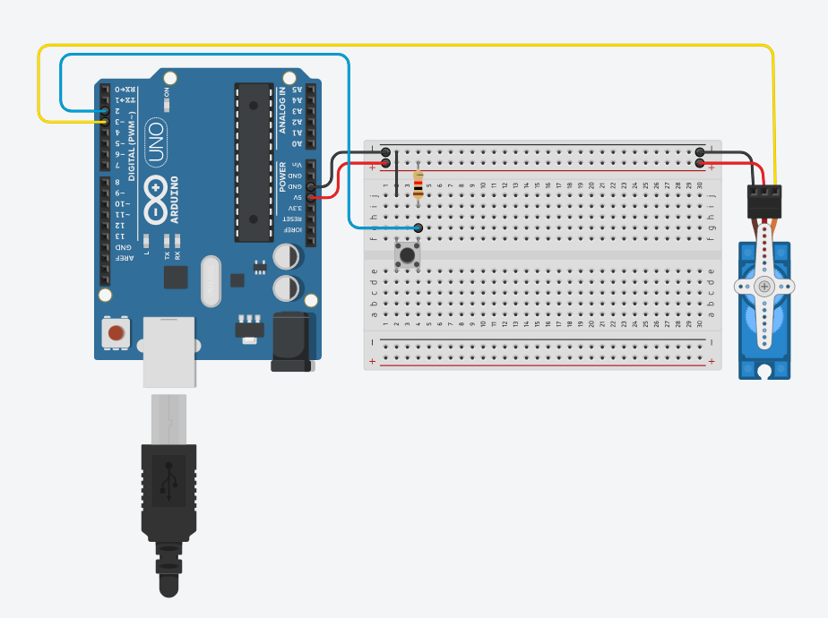

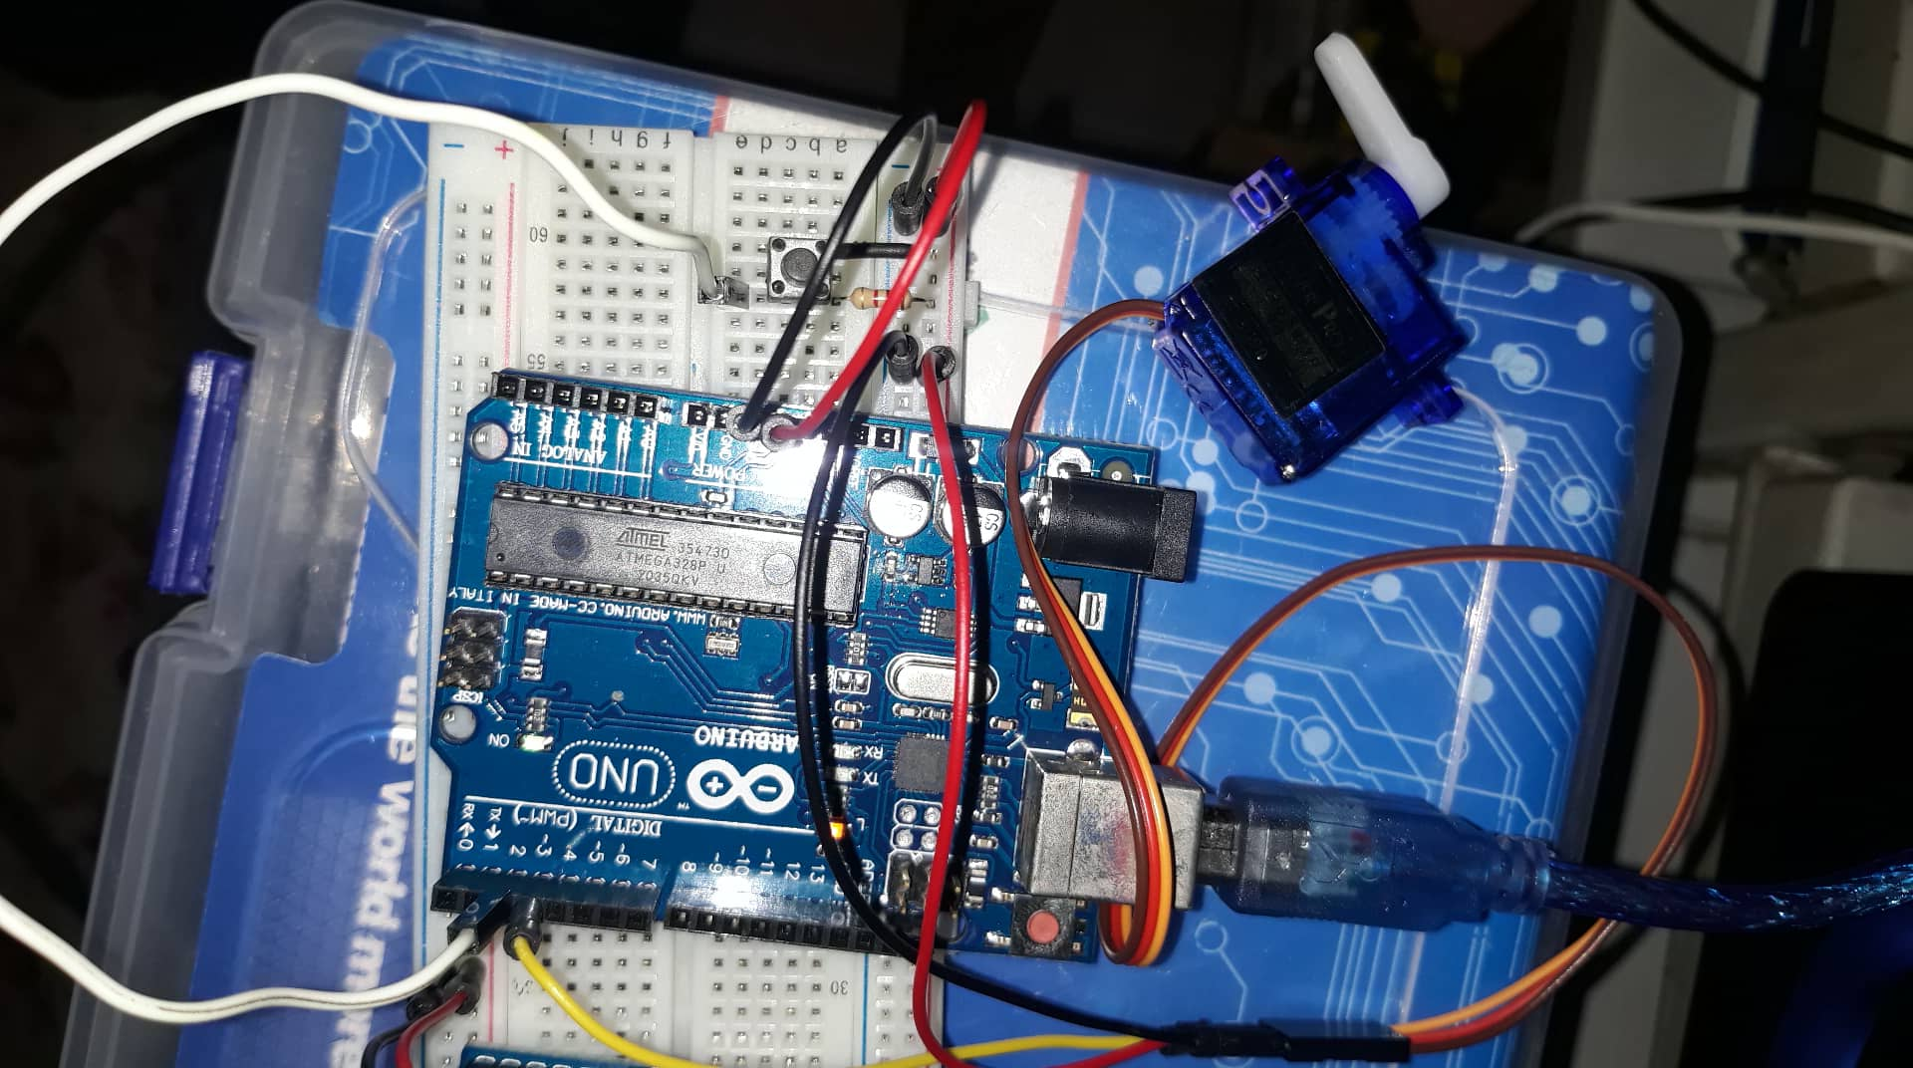

Observations: